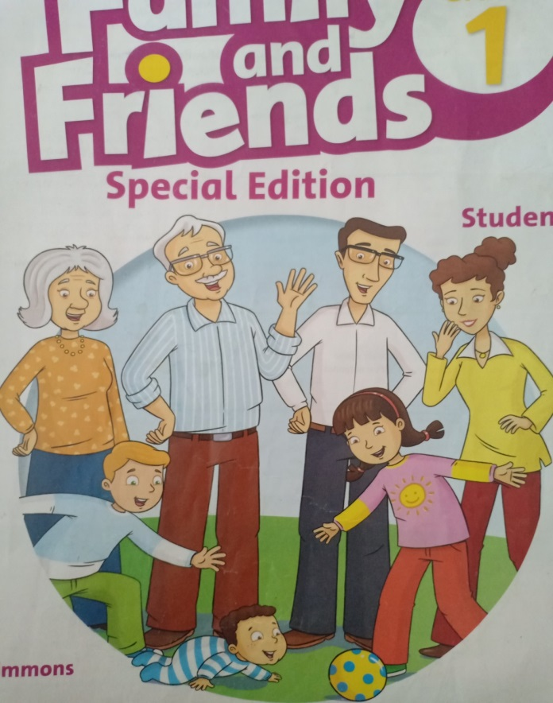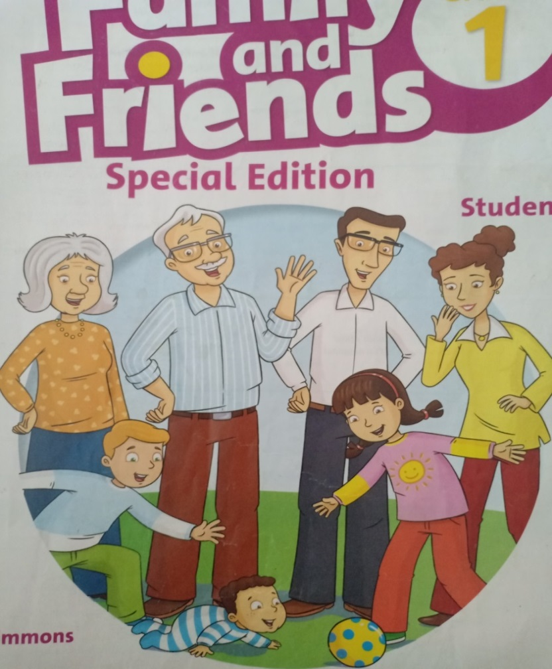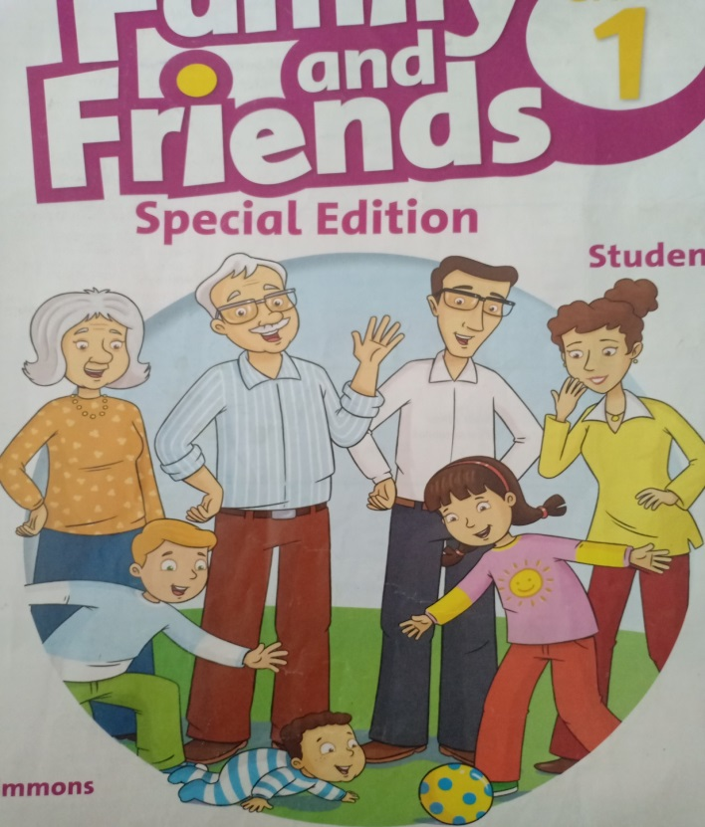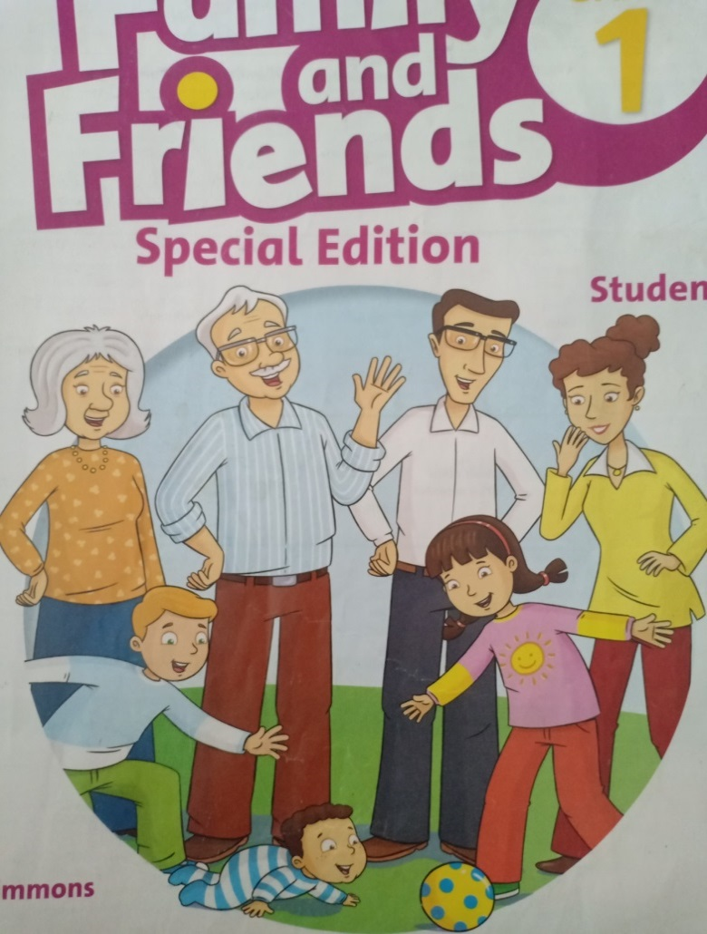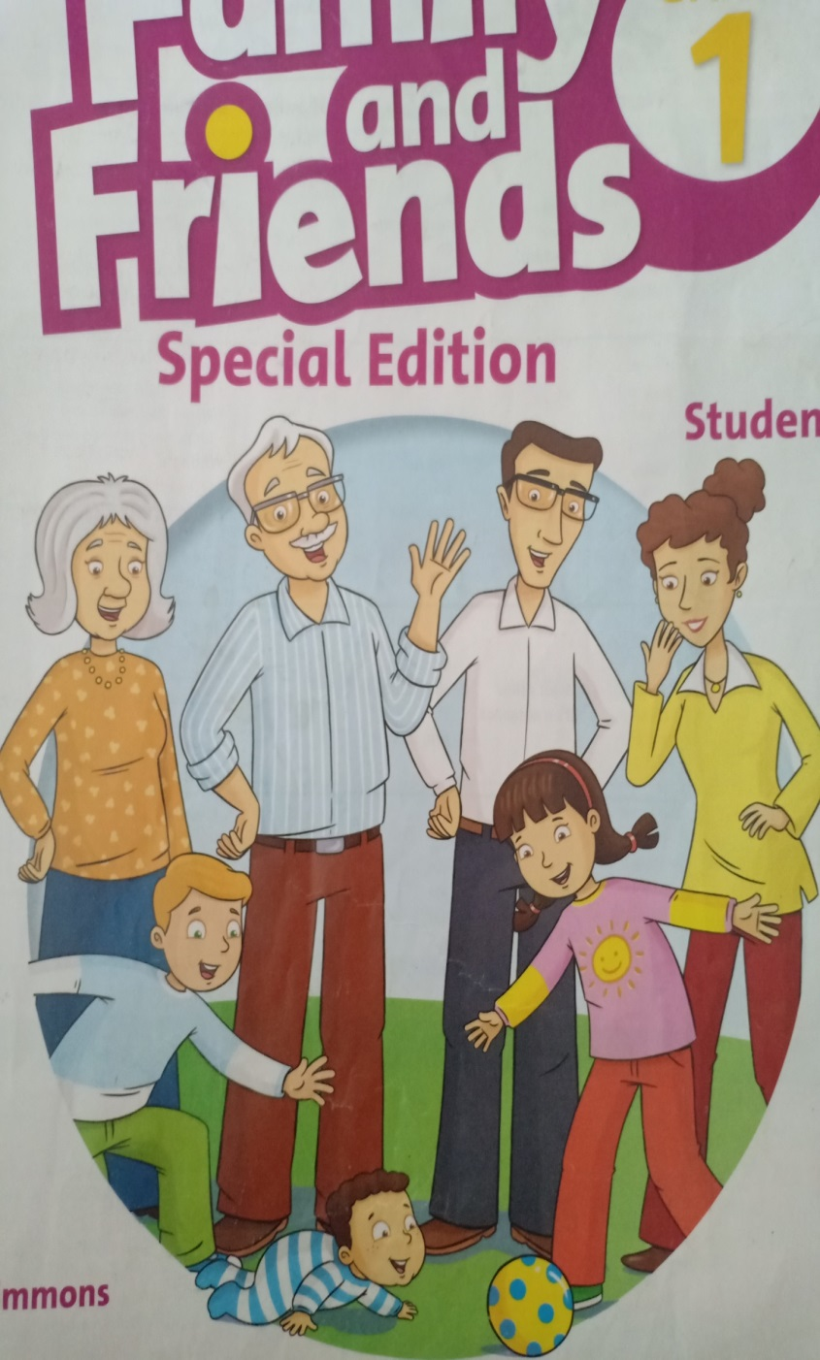

1.Look and write.

This is my __________

This is my __________

This is my __________

This is my __________

This is my __________

This is my ___dad__

mom dad brother sister grandma grandpa

Bài tập tiếng Anh khối 1

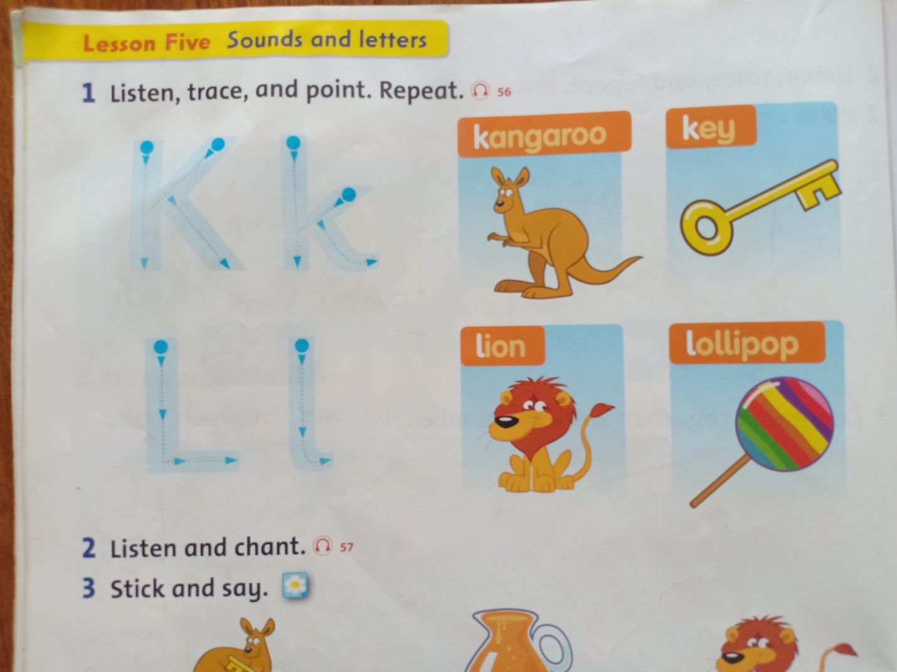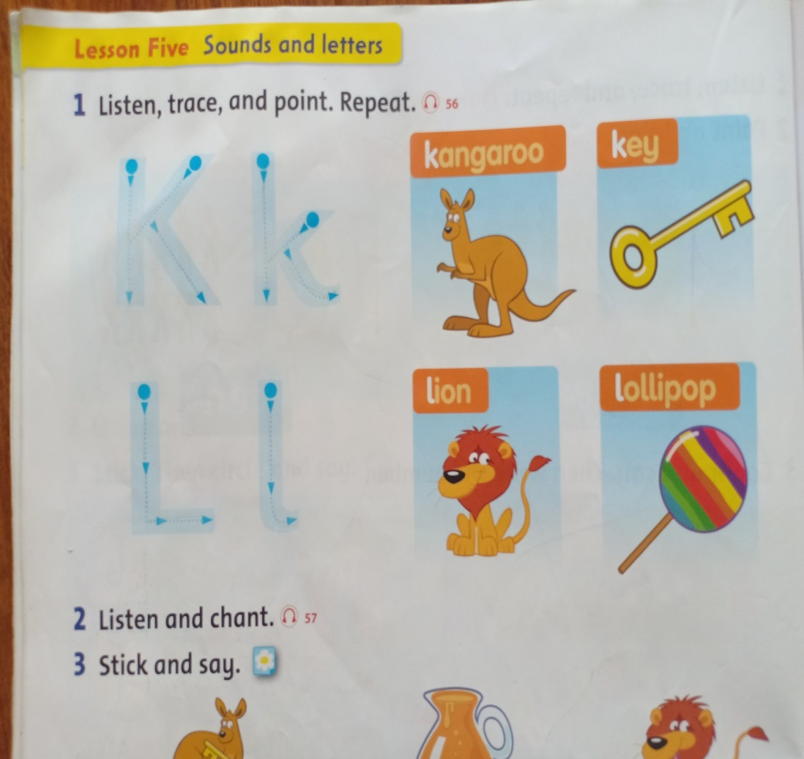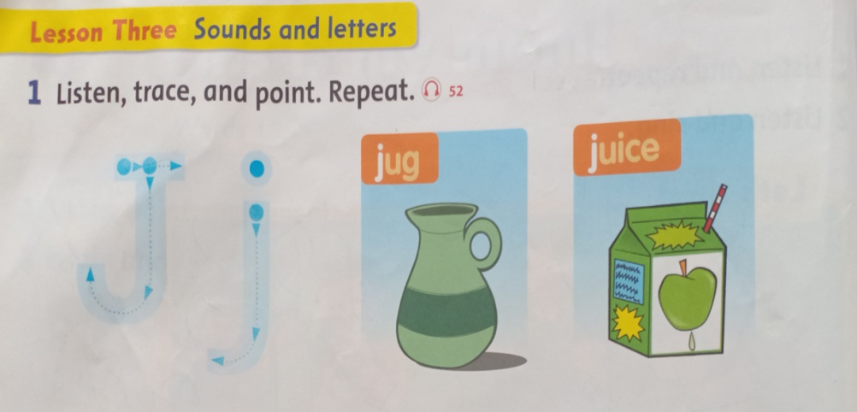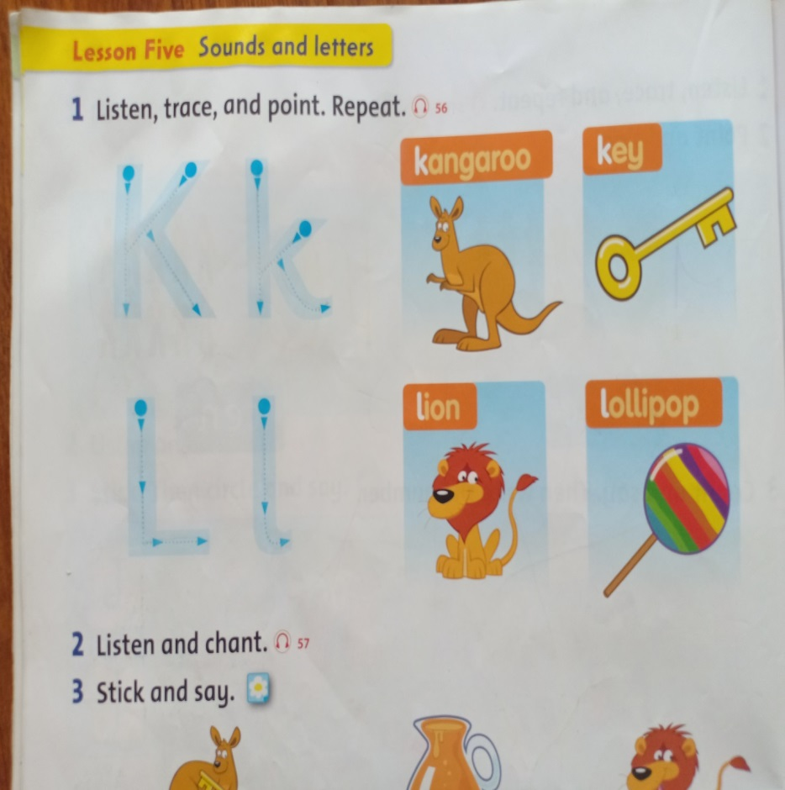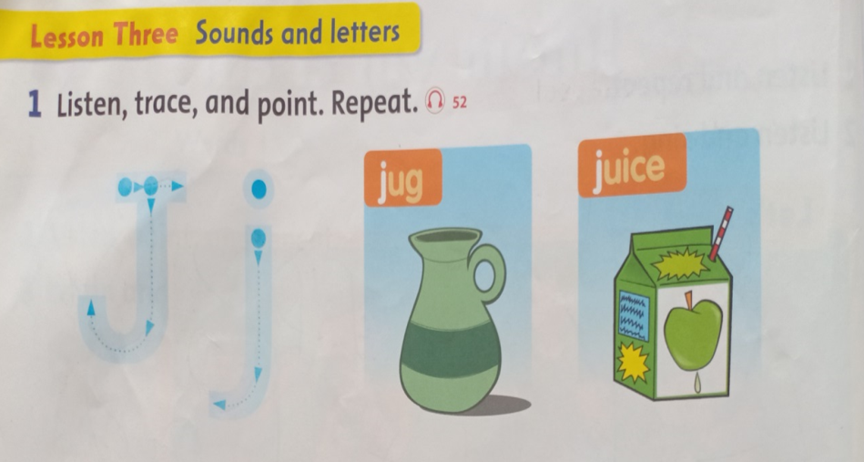

2.Look, match, write and say.

(nhìn, nối, viết và nói)

K

L

J

__ angaroo

__ ollipop

__ ug

K ey

__ uice

__ ion